1.CODE IN JYPYNP FORMAT:

A Jupyter Notebook (.ipynb file) is an interactive document that combines code, text, equations, visualizations, and interactive elements. It is commonly used for data science, machine learning, and research-based projects.

1. Structure of a .ipynb File

A Jupyter Notebook consists of cells, which can be of different types:

Markdown Cells: Used for documentation, explanations, and formatting (supports bold, italics, tables, and images).

Code Cells: Contain Python (or other languages) code that can be executed interactively.

Output Cells: Display results, including graphs, tables, and text.

Example of a Jupyter Notebook Cell Structure:

Markdown Cell Example:

# This is a Heading

## This is a Subheading

*Bold Text* and Italic Text

- Bullet Point 1

- Bullet Point 2

Code Cell Example (Python):

# Python code inside a Jupyter Notebook cell

import numpy as np

data = np.array([1, 2, 3, 4, 5])

print("Mean of data:", np.mean(data))

Output Cell Example:

Mean of data: 3.0

2. Why Use Jupyter Notebooks?

Interactive Execution: Run code in small parts instead of running an entire script.

Data Visualization: Easily integrate graphs and charts using matplotlib, seaborn, etc.

Documentation & Reports: Combines text and code in a single document.

Supports Multiple Languages: Python, R, Julia, and more.

Easy Sharing: Share .ipynb files via GitHub, Google Colab, or export them as PDFs/HTML files.

3. How to Open a .ipynb File?

Option 1: Using Jupyter Notebook (Locally)

1. Install Jupyter Notebook:

pip install notebook

2. Open Jupyter Notebook:

jupyter notebook

3. Select the .ipynb file from the browser interface.

How to Open a .ipynb File? (Continued)

Option 2: Using Google Colab (Online - No Installation Needed)

1. Go to Google Colab.

2. Click on "File" → "Upload Notebook" and select your .ipynb file.

3. The notebook will open in an interactive cloud environment.

Option 3: Using VS Code

1. Install the Jupyter extension in VS Code.

2. Open the .ipynb file directly in VS Code.

3. Run code cells interactively within the editor.

Option 4: Using Kaggle Notebooks

1. Go to Kaggle Notebooks.

2. Click "New Notebook", then upload your .ipynb file.

3. Run and edit it in Kaggle’s cloud environment.

4. Exporting Jupyter Notebooks

Jupyter Notebooks can be converted to other formats:

PDF: File → Download as → PDF

HTML: File → Download as → HTML

Python Script: File → Download as → .py

---

5. Common Libraries Used in Jupyter Notebooks

Data Manipulation: pandas, numpy

Visualization: matplotlib, seaborn, plotly

Machine Learning: scikit-learn, tensorflow, keras.

2.DATASET:

For a dataset related to Design Thinking and Critical Thinking, we can create one that includes survey responses, case studies, or assessments of individuals' thinking approaches.

Possible Dataset Structure

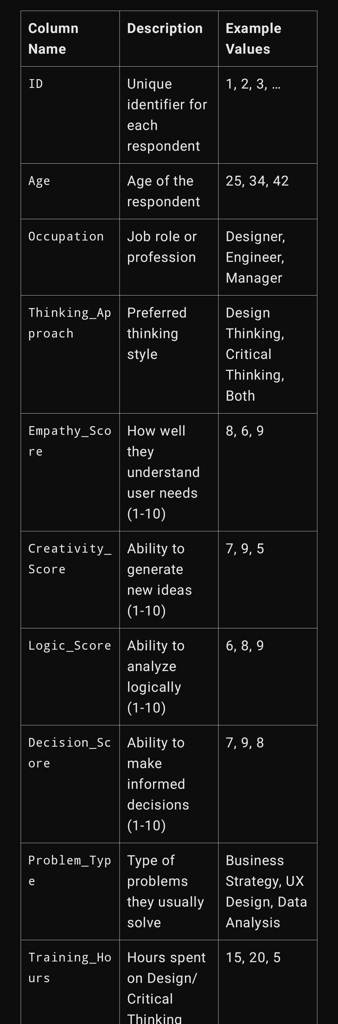

The dataset could contain the following fields:

Use Cases of This Dataset

Data Analysis: Find correlations between thinking styles and professions.

Machine Learning: Predict thinking preferences based on traits.

Visualization: Plot scores of creativity vs. logic to compare styles.

Sample Dataset: Design Thinking & Critical Thinking

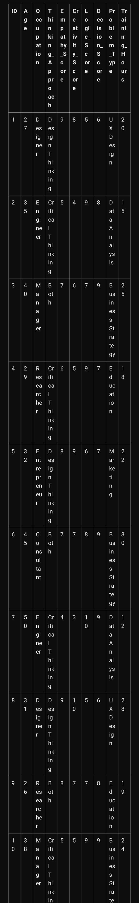

Insights from the Dataset

Design Thinking is more common among designers and entrepreneurs due to its focus on creativity and user experience.

Critical Thinking is preferred by engineers and researchers, as they require logical analysis and decision-making.

Managers and consultants often use both approaches to balance innovation with strategic decision-making.

Higher empathy and creativity scores correlate with Design Thinking, while higher logic and decision-making scores align with Critical Thinking.

3.A README FILE CONTAINING THE AIM AND RESULT:

Here is a README file for your dataset, including the aim and result.

---

README: Design Thinking & Critical Thinking Dataset

1. Aim

This dataset explores the relationship between Design Thinking and Critical Thinking across different professions. It examines how individuals score in key cognitive areas such as empathy, creativity, logic, and decision-making, as well as how training influences their approach to problem-solving.

2. Dataset Description

The dataset contains 50 entries with the following columns:

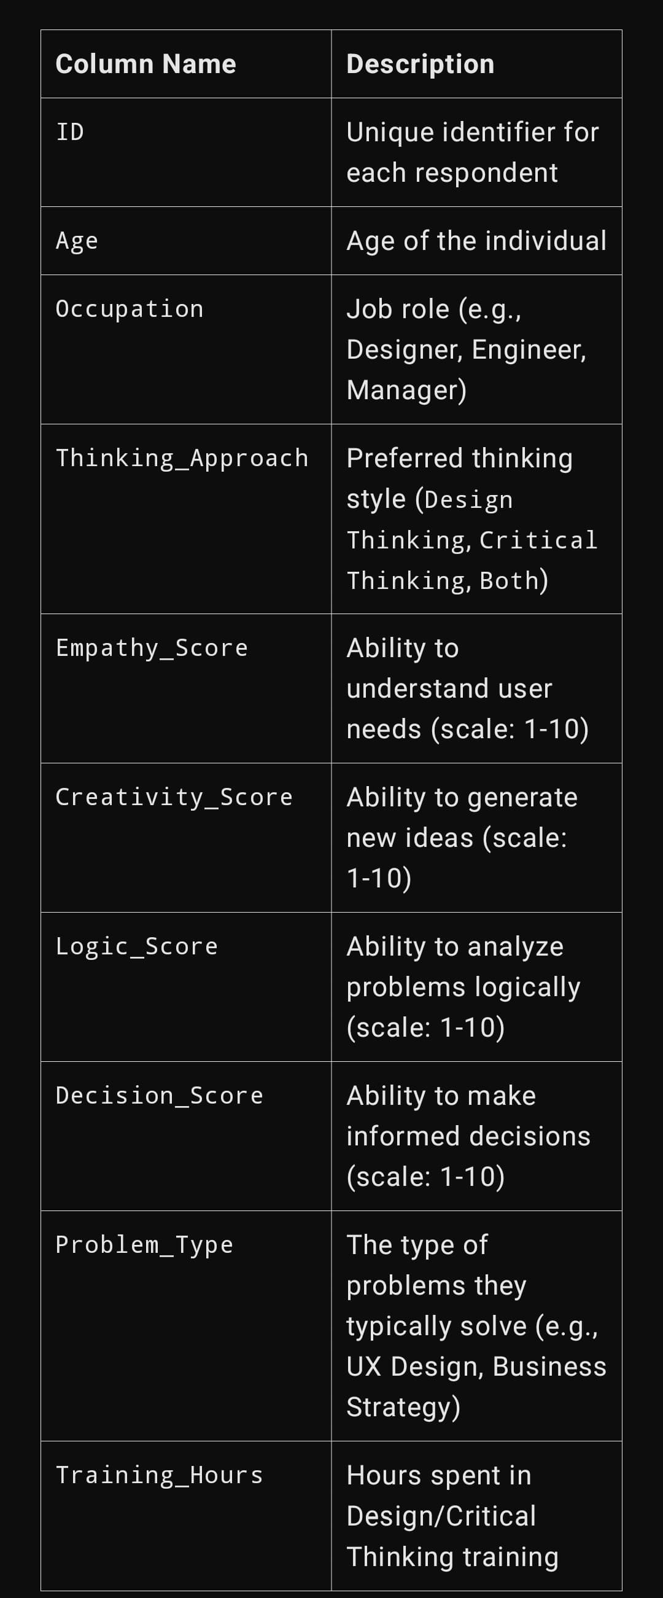

---

3. Result & Key Findings

1. Thinking Preferences by Profession:
2. Design Thinking is more common among Designers and Entrepreneurs, who score higher in creativity and empathy.
3. Critical Thinking is dominant among Engineers and Researchers, who score higher in logic and decision-making.
4. Managers and Consultants balance both approaches, as their roles require strategic thinking and innovation.
5. 2. Correlation Between Thinking Scores:
6. Higher creativity and empathy scores are linked to Design Thinking.
7. Higher logic and decision-making scores are associated with Critical Thinking.
8. Training improves scores, with those having 20+ training hours scoring better in their preferred thinking style.
9. 4. How to Use the Dataset
10. Data Analysis: Identify trends in thinking styles across different occupations.
11. Visualization: Plot correlations between empathy, creativity, and logic scores.
12. Machine Learning: Predict a person's thinking approach based on their scores and occupation.